SMART PARKING

INFRARED SENSOR

 An infrared sensor, also known as an IR sensor, works by detecting and measuring infrared radiation emitted or reflected by objects.

BLOCK DIAGRAM:

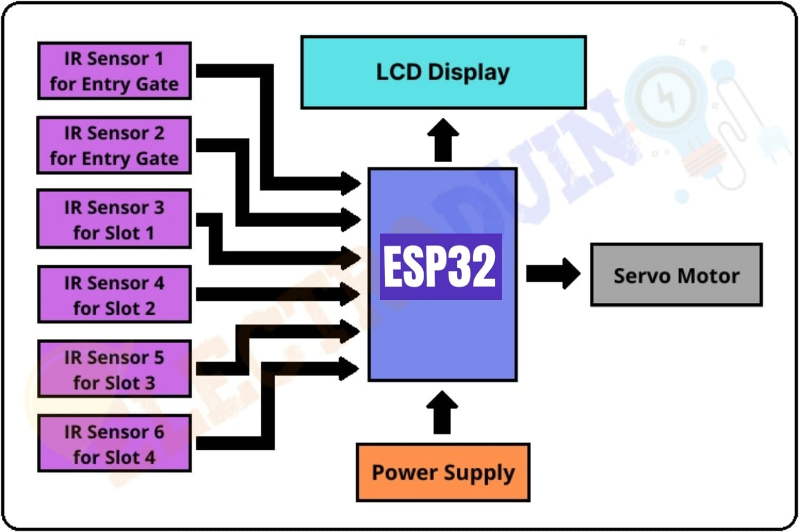

Infrared Emission: All objects with a temperature above absolute zero (-273.15°C or -459.67°F) emit infrared radiation in the form of heat. The hotter the object, the more infrared radiation it emits.

Detection: An IR sensor typically contains a component called a thermopile or a photodiode that is sensitive to infrared radiation. When this radiation strikes the sensor, it generates a tiny electrical voltage.

Conversion: The generated voltage is then converted into an electrical signal that can be processed by electronic circuitry. This signal is proportional to the intensity of the infrared radiation received.

Signal Processing: The electrical signal is processed to determine the presence, absence, or characteristics of objects or heat sources. This processing can involve amplification, filtering, and analog-to-digital conversion.

Output: The final output from the sensor can be used to trigger actions or provide data, such as detecting motion in a motion sensor.

PIN CONNECTION FOR IR SENSOR: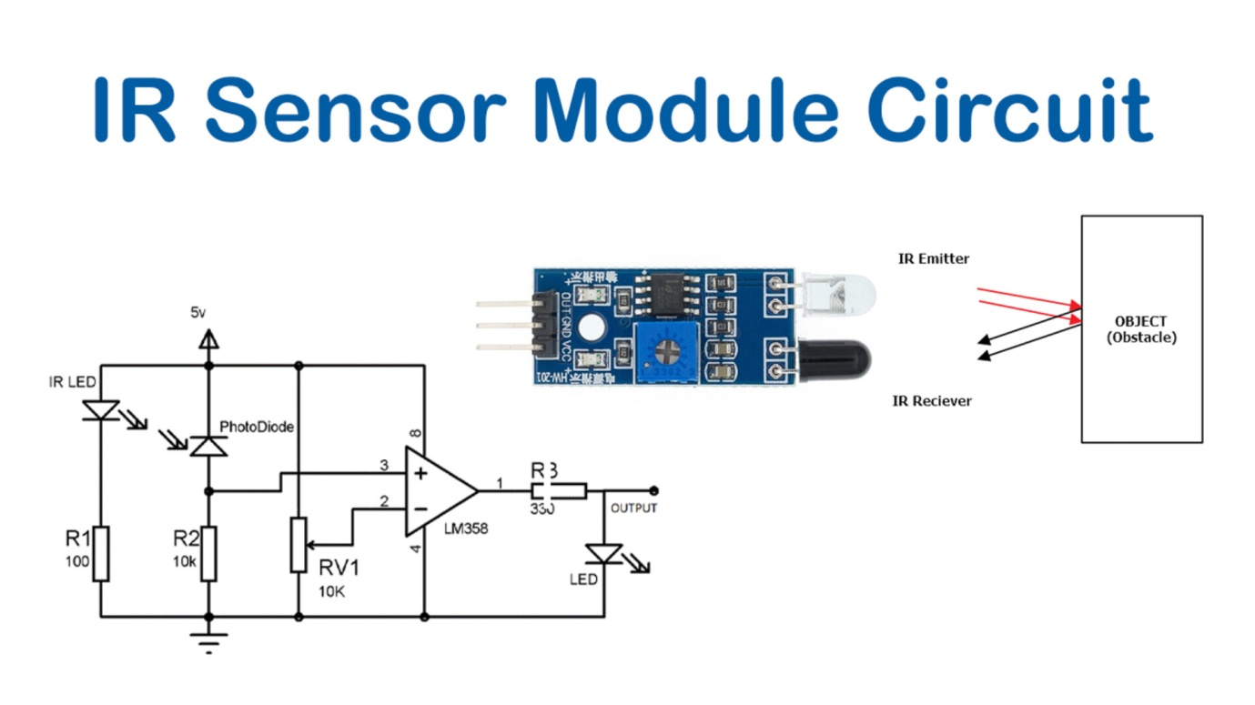

VCC (or VCC+): This pin is for the power supply. It is typically connected to a 3.3V or 5V power source, depending on the sensor's voltage requirements.

GND (or Ground): This pin is connected to the ground or 0V reference of your power source.

OUT (or Signal): This pin outputs the digital or analog signal based on the sensor's design. For digital output, it may provide a HIGH or LOW signal depending on whether an object is detected or not. For analog output, it can provide varying voltage levels corresponding to the distance or reflectance of the detected object.

CIRCUIT DIAGRAM:

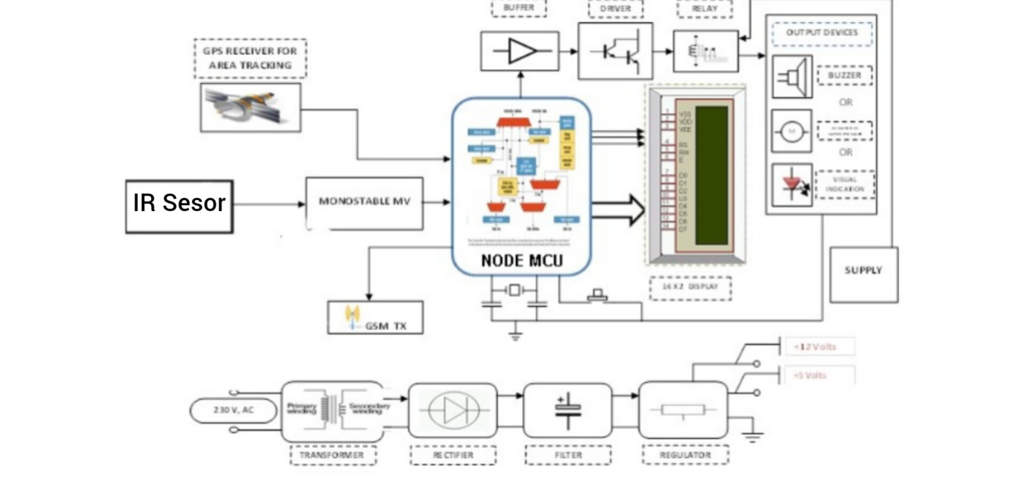

FEATURES:

**Security**: IR sensors can be used for security systems, such as intrusion detection.

**Light Sensing**: Some IR sensors can detect ambient light levels for automatic lighting control. Object Detection: IR sensors can detect the presence or absence of objects based on their infrared radiation. Proximity Sensing: They can determine the proximity of objects without physical contact.

**Motion Detection:** Some IR sensors are used for motion detection by sensing changes in infrared patterns.

**Temperature Measurement**: IR sensors can measure the temperature of objects based on their emitted IR radiation. **Remote Control**: IR sensors are used in devices like remote controls to transmit and receive signals.

## Obstacle Avoidance: They are often used in robotics and autonomous systems to